How to Find an Item in SearchOhio

- First, complete a Catalog search at Starklibrary.org. If we don’t have the item in our system, or the item is currently unavailable in our system, then click on Search other resources.
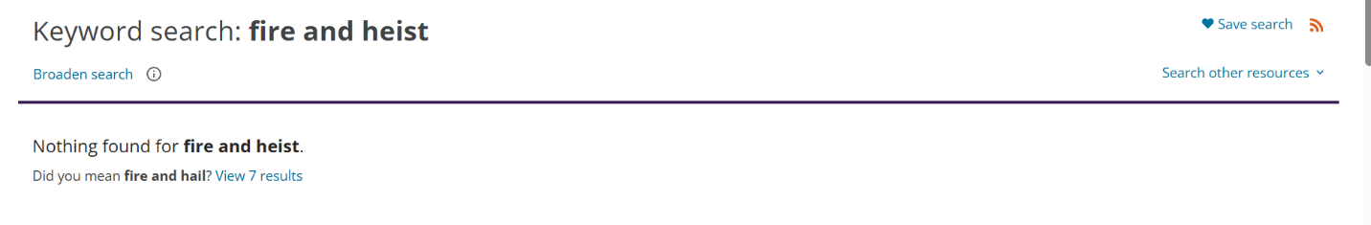

- Follow the links to the SearchOhio page.

- Log In at the top right (logging in later may reset your search).
NOTE: Stark Library does not require a PIN/Password to log into Search Ohio. Please leave this field blank.
- Use the Search box to locate an item.

- Filter your results using the facets on the left.

- Click Request on the Search Results page or on the record page.
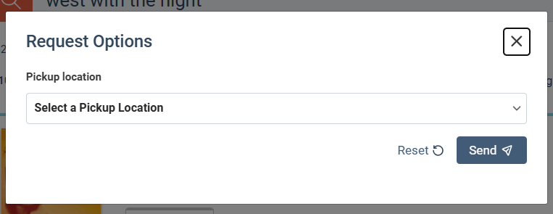
If a copy is available to request, a pop-up for choosing the pickup location appears. Select your location and hit Send.

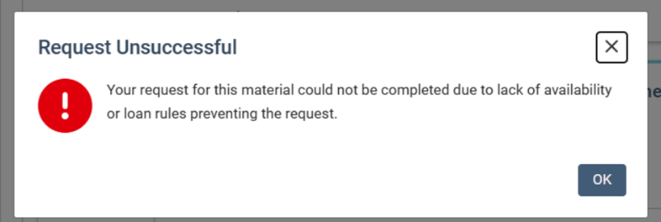

If no copies are available to borrow, an error message pop-up appears. Try another record or try again in a couple of weeks.

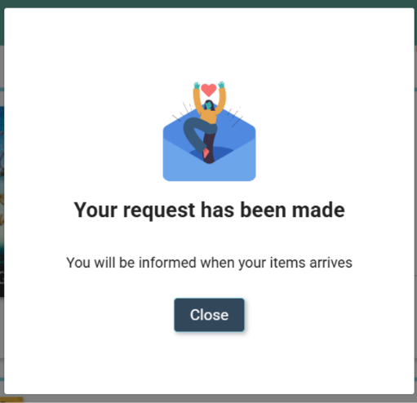
Successful requests get a celebratory popup. The request will automatically appear on your library account!

